CS4650

Assignment 4A: Detection

Alexander Kochman

October 21, 2024

**Part 1**

Images

Original Image Gaussian Filtered Image (sigma = .5)

This image is relatively smooth but has mild variations in noise. This type of noise resembles gaussian noise, so I chose to use a gaussian filter. Because the noise was very mild, I opted to use a small value for the standard deviation. This blurred the noise from the image to prepare it for blob detection without distorting the cells and their edges.

Original Image

Median Filtered Image (5x5 window)

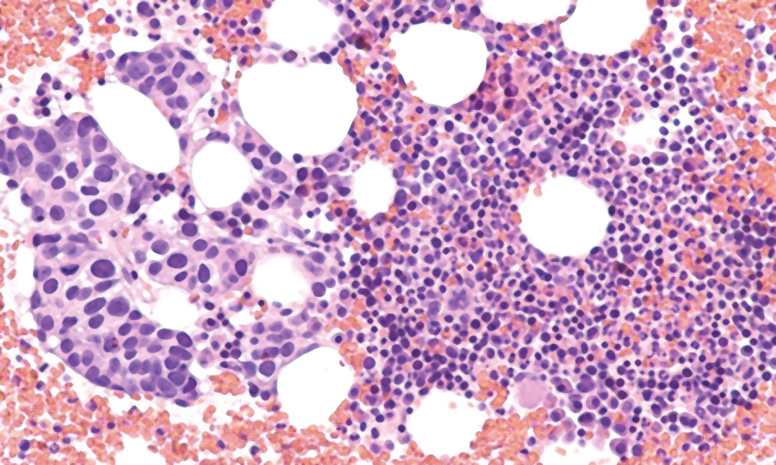

This image noise is slightly different than the Glomus Tumor image. It seems to be more granular, with many small intensity variations. This type of noise resembles salt-and-pepper noise, which can be filtered using a median filter. To test the effectiveness of the median filter, I observed the lighter purple areas between the cells that seemed to have the most obvious noise. Using a 5x5 filter effectively removed this noise without distorting the edges of the cells.

**Part 2**

Image 1 (Glomus Tumor)

The nuclei in this image were detected best at a 5x5 kernel scale. While the 3x3 and 7x7 filters also detected most of the blobs, the 3x3 included the most background “noise” in the binarized result and the 7x7 filter missed many of the smallest cells. This 5x5 scale produced a result that clearly shows the boundaries of the cells and the center of each.

Image 2 (Metastatic Cancer)

The nuclei in this image were smaller than the those in the last. Using a 3x3 kernel scale yielded the best results. It made the darker, purple blobs much more noticeable, round, and non-noisy than the pink blobs in the binarized result. This method of using a positive Laplacian of gaussian filter combined with a negative ensured that the brighter purple blobs were not confused with the pink blobs because they were extracted separately and then combined for the final result.

Discussion

The Laplacian of gaussian filter was effective at blob detection for images with relatively uniform blob sizes and intensities. The first image had slightly larger cells than the second, so using a 5x5 filter worked best, and the second image worked best with a 3x3 filter. However, each of these images had variations in the intensities and sizes of the blobs. So, while the filters did pick up on most of these outliers, the binarized result was not as clear for visualization. The best blobs were the standard ones, which yielded a white space around the center of the targeted location. These results are satisfactory because in each image, with the correct filter size and thresholding values, a binarized image was produced that can be used to show where every cell of interest is located. However, it should be noted that using the dark blob LoG output produced a much better result than the bright one, in large part due to the fact that the dark output was detecting the more visible cells.